COMPANY PROFILE
Company Name: EZ Trainings and Technologies Pvt. Ltd.

Introduction:
EZ Trainings and Technologies Pvt. Ltd. is a dynamic and innovative organization dedicated to providing comprehensive training solutions and expert development services. Established with a vision to bridge the gap between academic learning and industry requirements, we specialize in college trainings for students, focusing on preparing them for successful placements. Additionally, we excel in undertaking development projects, leveraging cutting-edge technologies to bring ideas to life.
Mission:
Our mission is to empower the next generation of professionals by imparting relevant skills and knowledge through specialized training programs. We strive to be a catalyst in the career growth of students and contribute to the technological advancement of businesses through our development projects.
Services:
College Trainings:
- Tailored training programs designed to enhance the employability of students.
- Industry-aligned curriculum covering technical and soft skills.
- Placement assistance and career guidance.
Development Projects:
- End-to-end development services, from ideation to execution.
- Expertise in diverse technologies and frameworks.
- Custom solutions to meet specific business needs.
Locations: Hyderabad | Delhi NCR
At EZ Trainings and Technologies Pvt. Ltd., we believe in transforming potential into excellence

ABSTRACT

- This project presents a Visa Application System designed to manage visa applications efficiently. The system employs Python programming language, utilizing JSON for data storage. It offers functionalities for creating, reading, updating, deleting, processing visa applications, and tracking application statuses.
- The system is encapsulated within a Python class named VisaApplicationSystem. Upon instantiation, it loads existing visa applications from a JSON file if available. Users interact with the system through a command-line interface.
- The core functionalities of the system include:
- Creating Visa Applications: Users can input details such as passport number, application ID, status ID, and countries involved to create new visa applications. Upon creation, the application is appended to the list of applications and saved to the JSON file.
- Reading Visa Applications: Users can retrieve the details of a specific visa application by providing its application ID. The system searches through existing applications and displays the details if found.
- Updating Visa Applications: Users can update specific fields of a visa application, such as passport number, status ID, or countries involved. The system searches for the application by its ID, applies the updates, and saves the changes to the JSON file.
- Deleting Visa Applications: Users can remove a visa application from the system by providing its application ID. The system locates the application, deletes it from the list, and updates the JSON file accordingly.
- Processing Visa Applications: This functionality marks a visa application as processed. Users input the application ID, and the system updates the status ID of the application to "Processed" and saves the changes.
- Tracking Application Status: Users can view all visa applications with a specific status ID. The system filters applications based on the provided status ID and displays relevant details.
- The system ensures data persistence by saving application details to a JSON file after every modification operation. Error handling is implemented to manage scenarios such as file not found or application not found.
- The command-line interface guides users through various options, enabling seamless interaction with the system. This Visa Application System can be utilized by visa processing agencies, embassies, or any entity involved in managing visa applications to streamline their processes and enhance efficiency.
Introduction to the Project

A Movie Ticket Booking System Project in Python is a digital platform that allows customers to access the services of a business, reserve seats and buy tickets.this platform provides details such as what time a movie will be played, what seats are available, movie previews and so much more.It includes several features that allow users to reserve movie tickets and provide information about movies. The principle of this system, as well as the Python application, is quite obvious.

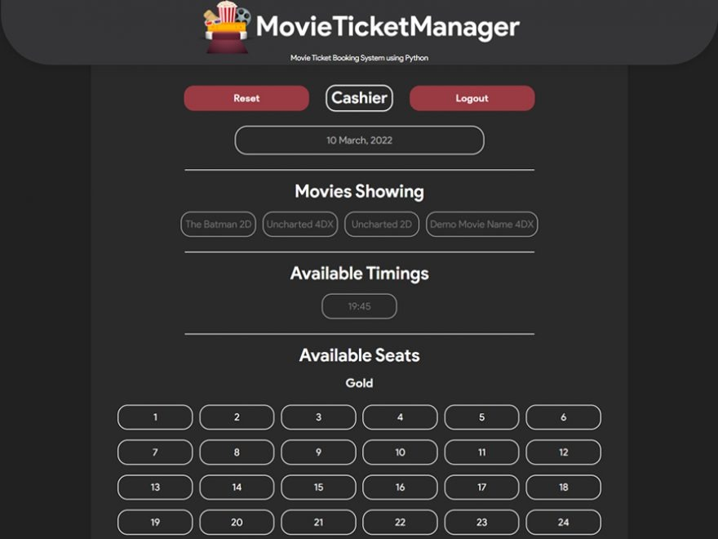

Methodology

Functions:

A function is a block of code which only runs when it is called.
You can pass data, known as parameters, into a function.

Syntax:

def my_function():
print("Hello from a function")

In this program we have defined various functions like
- initialize_seat_matrix():
- display_seat_matrix(seats):
- select_seats(seats,num_tickets):
- t_movie():

Try and Catch Mechanism:
When an error occurs, or exception as we call it, Python will normally stop and generate an error message.

These exceptions can be handled using the try statement:

try:
print(var)
except:
print(“ ")

Two Dimensional Arrays:
A 2D array is also known as a matrix (a table of rows and columns).

Syntax:

datatype matrix_name[x][y] = { {}, {} };

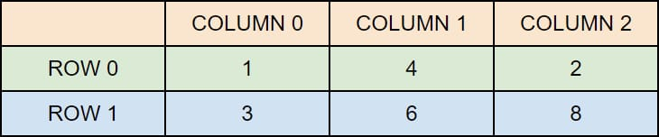

Algorithm

FUNCTION initialize_seat_matrix()
RETURN a 5x5 matrix filled with 'O' (available seats)

FUNCTION display_seat_matrix(seats)
PRINT "Current seat availability (O = Available, X = Booked):"
FOR each row in seats
PRINT the row as a space-separated string
PRINT an empty line for readability

FUNCTION select_seats(seats, num_tickets)
CREATE an empty list selected_seats
FOR each ticket from 1 to num_tickets
TRY
PROMPT user for row input (1-5)
PROMPT user for column input (1-5)
CONVERT inputs to zero-based indices
IF seats[row][col] == 'O' THEN
SET seats[row][col] to 'X' // Mark as booked
APPEND (row + 1, col + 1) to selected_seats
PRINT success message for the booked seat
CALL display_seat_matrix(seats)
ELSE
PRINT "Seat is already booked."
ENDIF
CATCH ValueError or IndexError
PRINT "Invalid input."
ENDTRY
RETURN selected_seats

FUNCTION t_movie()
PRINT "Which movie do you want to watch?"
PRINT options for movies
TRY
PROMPT user for movie choice (1-4)
IF movie choice is 4 THEN
CALL center() // Go back to theater selection
ELSE
CALL theater() // Proceed to theater selection
ENDIF
CATCH ValueError
PRINT "Invalid input."
CALL t_movie()

FUNCTION theater()
PRINT "Which screen do you want to watch the movie on?"
PRINT options for screens
TRY
PROMPT user for screen choice (1-3)
PROMPT user for number of tickets
CALL timing(screen, tickets)
CATCH ValueError
PRINT "Invalid input."
CALL theater()

FUNCTION timing(screen, num_tickets)
DEFINE time options for each screen
IF screen is valid THEN
PRINT "Choose your time:"
FOR each time option
PRINT time options for the selected screen
ENDFOR
TRY
PROMPT user for time choice (1-4)
IF time choice is valid THEN
PRINT selected time
SET seats = CALL initialize_seat_matrix()
CALL display_seat_matrix(seats)
SET selected_seats = CALL select_seats(seats, num_tickets)
PRINT successfully booked seats
PRINT "Enjoy your movie!"
ELSE
PRINT "Invalid time selection."
CALL timing(screen, num_tickets)
ENDIF
CATCH KeyError
PRINT "Invalid input."
CALL timing(screen, num_tickets)
ELSE
PRINT "Invalid screen choice."
CALL theater()

FUNCTION movie(theater_choice)
IF theater_choice is in [1, 2, 3] THEN
CALL t_movie()
ELSE IF theater_choice is 4 THEN
CALL city() // Go back to city selection
ELSE
PRINT "Invalid choice."
CALL center()

FUNCTION center()
PRINT "Which theater do you wish to see a movie at?"
PRINT options for theaters
TRY
PROMPT user for choice (1-4)
CALL movie(choice)
CATCH ValueError
PRINT "Invalid input."
CALL center()

FUNCTION city()
PRINT "Hi, welcome to movie ticket booking!"
PRINT "Where do you want to watch a movie?"
PRINT options for cities
TRY
PROMPT user for place choice (1-3)
IF place is valid THEN
CALL center()
ELSE
PRINT "Invalid choice."
CALL city()
ENDIF
CATCH ValueError
PRINT "Invalid input."
CALL city()

// Start the process
CALL city()

Source Code:

def initialize_seat_matrix():
return [['O' for _ in range(5)] for _ in range(5)]

def display_seat_matrix(seats):
print("\nCurrent seat availability (O = Available, X = Booked):")
for row in seats:
print(' '.join(row))
print()

def select_seats(seats, num_tickets):
selected_seats = []
for _ in range(num_tickets):
try:
row = int(input("Enter seat row (1-5): ")) - 1
col = int(input("Enter seat column (1-5): ")) - 1
if seats[row][col] == 'O':
seats[row][col] = 'X'
selected_seats.append((row + 1, col + 1))
print(f"Seat ({row + 1}, {col + 1}) successfully booked.")
display_seat_matrix(seats)
else:
print("Seat is already booked, please select another seat.")
continue
except (ValueError, IndexError):
print("Invalid input. Please select a valid seat.")
continue
return selected_seats

def t_movie():
print("Which movie do you want to watch?")
print("1. Kalki 2898 AD")
print("2. Devara Part 1")
print("3. Okkadu Re-Release")
print("4. Back")

try:
movie = int(input("Choose your movie (1-4): "))
if movie == 4:
center()
else:
theater()
except ValueError:
print("Invalid input, please choose a valid option.")
t_movie()

def theater():
print("Which screen do you want to watch the movie on?")
print("1. SCREEN 1")
print("2. SCREEN 2")
print("3. SCREEN 3")

try:
screen = int(input("Choose your screen (1-3): "))
tickets = int(input("Number of tickets you want?: "))
timing(screen, tickets)
except ValueError:
print("Invalid input, please enter valid choices.")
theater()

def timing(screen, num_tickets):
time1 = {
"1": "10:00AM - 1:00PM",
"2": "1:10PM - 4:10PM",
"3": "4:20PM - 7:20PM",
"4": "7:30PM - 10:30PM"
}
time2 = {
"1": "10:15AM - 1:15PM",
"2": "1:25PM - 4:25PM",
"3": "4:35PM - 7:35PM",
"4": "7:45PM - 10:45PM"
}
time3 = {
"1": "10:30AM - 1:30PM",
"2": "1:40PM - 4:40PM",
"3": "4:50PM - 7:50PM",
"4": "8:00PM - 10:45PM"
}

time_options = {1: time1, 2: time2, 3: time3}

if screen in time_options:
print("Choose your time:")
for k, v in time_options[screen].items():
print(f"{k}. {v}")
try:
time_choice = input("Select your time (1-4): ")
if time_choice in time_options[screen]:
print(f"Selected time: {time_options[screen][time_choice]}")
seats = initialize_seat_matrix()
display_seat_matrix(seats)
selected_seats = select_seats(seats, num_tickets)
print(f"Successfully booked seats: {selected_seats}")
print(f"Enjoy your movie at {time_options[screen][time_choice]}!")
else:
print("Invalid time selection. Please try again.")
timing(screen, num_tickets)
except KeyError:
print("Invalid input. Please select a valid time.")
timing(screen, num_tickets)
else:
print("Invalid screen choice.")
theater()

def movie(theater_choice):
if theater_choice in [1, 2, 3]:
t_movie()
elif theater_choice == 4:
city()
else:
print("Invalid choice.")
center()

def center():
print("Which theater do you wish to see a movie at?")
print("1. PVR INOX")
print("2. Asian ALLU ARJUN")
print("3. Asian Mahesh Babu")
print("4. Back")

try:
choice = int(input("Choose your option (1-4): "))
movie(choice)
except ValueError:
print("Invalid input, please choose a valid option.")
center()

def city():
print("Hi, welcome to movie ticket booking!")
print("Where do you want to watch a movie?")
print("1. Bengaluru")
print("2. Hyderabad")
print("3. Chennai")

try:
place = int(input("Choose your option (1-3): "))
if place in [1, 2, 3]:
center()
else:
print("Invalid choice, please select again.")
city()
except ValueError:
print("Invalid input, please enter a number.")
city()

city()

Output:

''' OUTPUT :
Hi, welcome to movie ticket booking!
Where do you want to watch a movie?
1. City 1
2. City 2
3. City 3
Choose your option (1-3): 1
Which theater do you wish to see a movie at?
1. Inox
2. Icon
3. PVP
4. Back
Choose your option (1-4): 3
Which movie do you want to watch?
1. Movie 1
2. Movie 2
3. Movie 3
4. Back
Choose your movie (1-4): 1
Which screen do you want to watch the movie on?
1. SCREEN 1
2. SCREEN 2
3. SCREEN 3
Choose your screen (1-3): 1
Number of tickets you want?: 2
Choose your time:
1. 10:00 - 1:00
2. 1:10 - 4:10
3. 4:20 - 7:20
4. 7:30 - 10:30
Select your time (1-4): 1
Selected time: 10:00 - 1:00

Current seat availability (O = Available, X = Booked):
O O O O O
O O O O O
O O O O O
O O O O O
O O O O O

Enter seat row (1-5): 1
Enter seat column (1-5): 3
Seat (1, 3) successfully booked.

Current seat availability (O = Available, X = Booked):
O O X O O
O O O O O
O O O O O
O O O O O
O O O O O

Enter seat row (1-5): 1
Enter seat column (1-5): 2
Seat (1, 2) successfully booked.
Current seat availability (O = Available, X = Booked):
O X X O O
O O O O O
O O O O O
O O O O O
O O O O O

Successfully booked seats: [(1, 3), (1, 2)]
Enjoy your movie at 10:00 - 1:00!

Conclusion :

The code defines a simple movie ticket booking system
with functions for selecting a city, theater, movie, screen,
timing, and booking seats. It uses basic input/output to
interact with the user and manages state through a seat
matrix and lists of selected seats. Error handling is
included to guide users through valid inputs.

Bibliography:

- Teacher’s Guidance
- www.python.org-beginner
- www.docspython.org
- www.geeksforgeeks.com

